- Demonstrate use of git commands to push and pull 3 html files from Github account.
mkdir Demo
cd Demo
echo "<h1>Home Page</h1>" > index.html
echo "<h1>About Us</h1>" > about.html
echo "<h1>Contact</h1>" > contact.html
git init
git add .
git commit -m "Initial commit: Added 3 HTML files"
git remote add origin https://github.com/pro17/EXP1DEMO.git
git branch -M main
git push -u origin main
git clone https://github.com/pro17/EXP1DEMO.git
cd EXP1DEMO
git pull origin main
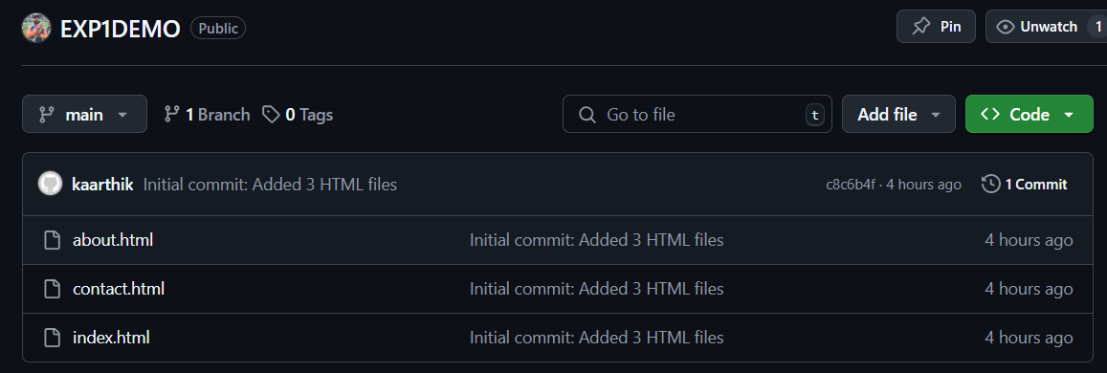

- Demonstrate Building java program (addition of 2 numbers) through Jenkins.
• Jenkins Dashboard → New Item
• Name: AdditionPipeline
• Select Pipeline → OK
• In Pipeline section, choose “Pipeline script”

pipeline {
agent any
stages {
stage('Compile') {
steps {
writeFile file: 'Addition.java', text: '''
public class Addition {
public static void main(String[] args) {
int a = 10, b = 20;
int sum = a + b;
System.out.println("The sum is: " + sum);
}
}
'''
bat 'javac Addition.java'
}
}
stage('Run') {
steps {
bat 'java Addition'
}
}
}
}

• Paste the above Jenkinsfile content
• Click Save → Click Build Now

- Demonstrate Continuous Integration process in Jenkins. Build a java program every 2 minutes (addition of two numbers) residing in Github repository.

Create Addition.java in GitHub Repository

public class Addition {
public static void main(String[] args) {
int a = 10, b = 20;
int sum = a + b;
System.out.println("The sum is: " + sum);
}
}

Go to Jenkins dashboard → New Item → Enter a name (e.g., Java_Addition_CI) → Choose Freestyle project → OK.

• Under Source Code Management, select Git.
Change master to main
• Enter the GitHub repository URL: https://github.com/your-username/your-repo.git
• Scroll to Build Triggers.
• Check Build periodically.
• Enter this in the schedule box: H/2 * * * *
Go to Build → Add build step → Execute shell (Linux/macOS) or Execute Windows batch command (on Windows).

javac Addition.java
java Addition

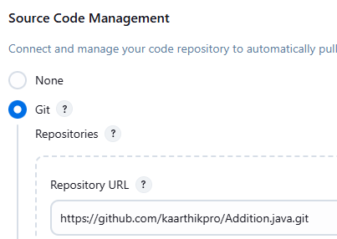
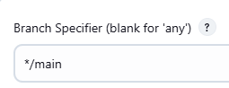
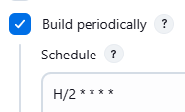
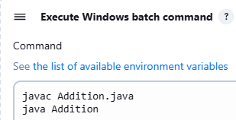

- Demonstrate CI/CD in Jenkins. Consider 3 html files in Github repository and write a scripted pipeline to deploy on Xampp server.
https://github.com/username/html-website
|
|-- index.html
|-- about.html
|-- contact.html

<!DOCTYPE html>
<html>
<head><title>About</title></head>
<body><h1>About Us</h1></body>
</html>
<!DOCTYPE html>
<html>
<head><title>Contact</title></head>
<body><h1>Contact Us</h1></body>
</html>
<!DOCTYPE html>
<html>
<head><title>Home</title></head>
<body><h1>Welcome to the Home Page</h1></body>
</html>

Pipeline script:

node {
stage('Clone Repository') {
git credentialsId: 'github-pat', url: 'https://github.com/kaarthikpro/EXP-4-LAB-EXAM.git', branch: 'main'
}

stage('Deploy to XAMPP') {
def xamppPath = 'C:/xampp/htdocs/mywebsite'

// Create directory if not exists
bat "if not exist \"${xamppPath}\" mkdir \"${xamppPath}\""

// Copy HTML files
bat "copy index.html \"${xamppPath}\\\""
bat "copy about.html \"${xamppPath}\\\""
bat "copy contact.html \"${xamppPath}\\\""
}

stage('Deployment Completed') {
echo 'Website deployed successfully to XAMPP!'
echo 'Visit http://localhost/mywebsite/index.html to view it.'
}
}

6. Write a Selenium script to perform automated testing.

# test_script.py

from selenium import webdriver
from selenium.webdriver.common.keys import Keys
import time
driver=webdriver.Chrome()
driver.get("https://www.google.com")
search_box=driver.find_element("name","q")
search_box.send_keys ("Ramrao Adik institute of technology")
search_box.send_keys (Keys.RETURN)
time.sleep(10)

- Demonstrate CI/CD in Jenkins. Consider 3 html files in Github repository and write a declarative pipeline to deploy on Xampp server.

- Go to Jenkins Dashboard → Manage Jenkins → Credentials → (Global).
- Click "Add Credentials".
- Select:
  - Kind: Username with password
  - Username: GitHub username
  - Password: GitHub Personal Access Token (PAT)
  - ID: github-creds
- Save.

🆕 3. Create New Pipeline Job
- Go to Jenkins Dashboard.
- Click “New Item”.
- Enter a name: DeployHTMLtoXAMPP.
- Choose Pipeline.
- Click OK.

Pipeline script:
pipeline {
agent any

environment {
DEPLOY_DIR = 'C:\\xampp\\htdocs\\mywebsite'
}

stages {
stage('Clone Repository') {
steps {
git credentialsId: 'github-creds', branch: 'main', url: 'https://github.com/kaarthikpro/EXP-4-LAB-EXAM.git'
}
}

stage('Prepare Deployment Directory') {
steps {
bat """
if not exist "%DEPLOY_DIR%" mkdir "%DEPLOY_DIR%"
"""
}
}

stage('Deploy HTML Files to XAMPP') {
steps {
bat """
copy /Y index.html "%DEPLOY_DIR%"
copy /Y about.html "%DEPLOY_DIR%"
copy /Y contact.html "%DEPLOY_DIR%"
"""
}
}

stage('Deployment Completed') {
steps {
echo "Visit: http://localhost/mywebsite/index.html"
}
}
}

post {
success {
echo '✅ CI/CD completed successfully!'
}
failure {
echo '❌ Deployment failed.'
}
}
}

7.Create an image of php project and push on Dockerhub repository.

Folder:

Dockerfile :

# Use PHP with Apache
FROM php:8.2-apache

# Set working directory
WORKDIR /var/www/html

# Copy PHP file to Apache root
COPY hello.php .

# Set correct permissions
RUN chown -R www-data:www-data /var/www/html \
&& chmod -R 755 /var/www/html

EXPOSE 80

hello.php :

<!DOCTYPE html>
<html lang="en">
<head>
<meta charset="UTF-8">
<meta name="viewport" content="width=device-width, initial-scale=1.0">
<title>PHP Docker</title>
</head>
<body>
<h1><?php echo "Hello world from a PHP container"; ?></h1>
</body>
</html>

docker build -t pro17/php-project .
docker login
docker push pro17/php-project
http://localhost:5000/hello.php
docker build -t php-docker-demo .
docker run -d -p 5000:80 php-docker-demo

http://localhost:5000/hello.php

